Project Report On

**MICROCONTROLLERS AND INTERFACING TECHNIQUES TERM PROJECT**



307L-Microprocessor Based System Design

Department of Computer System Engineering

University of Engineering and Technology Peshawar

Submitted to: **Sir Shahzada Fahim Jan**

Submitted by:

**Muhammad Umar Jan 21PWCSE2000**

**Muhammad Saad 21PWCSE1997**

**Ayman Maab 21PWCSE2076**

**Section ‘B’**

Date: **Thu, June 27, 2024**

**MICROCONTROLLERS AND INTERFACING TECHNIQUES TERM PROJECT**

**1.Abstract**

A Temperature Controlled DC Fan Is a system which automatically turns on a DC Fan when the ambient temperature increases above a certain limit. Generally, electronic devices produce more heat. So this heat should be reduced in order to protect the device.

The aim of this project Is to design a temperature controlled fan using LPC2148 microcontroller, in which the *fan is automatically turned ON or OFF* according to the temperature and also the *temperature limit can be changed* anytime using input from *UART* .

In this circuit, the *LM35* temperature sensor is used to get the *temperature sensed*. Then, the temperature is displayed on the LCD.

Like this, the microcontroller will continuously monitor the temperature. If the temperature exceeds *more than 35 degree Celsius* (upper safe temperature limit of laptops), the microcontroller will turn on the relay to *start the fan*.

If the temperature drops *below 35 degree Celsius*, the microcontroller will turn off the relay , but the *fan speed will slow down gradually* which further reduces the temperature.

**2. Introduction**

*Maintaining an optimal room temperature is crucial for comfort and energy efficiency in modern homes. Traditional fans with manual speed control are not responsive to changing room temperatures, leading to inefficient energy usage. This project aims to develop an intelligent fan system using an 8051 microcontroller that automatically adjusts its speed based on real-time temperature readings. The system will enhance user comfort and reduce energy consumption by optimizing fan operation.*

**3.Configuration :**

1. Pin 2 is the *data pin of LM35* which is connected to the analog input pin **P0.27** i.e. ADC0. Pin 1 to 5V power supply and Pin 3 to Ground.
2. As temperature changes, the output of the ADC is generated. The digital output of the ADC is given to Microcontroller to control the fan accordingly.
3. The *last 4 data pins of the LCD* are connected to **P0.12** to **P0.15** of the microcontroller. Pin 1 and 3 to Ground and Pin 2 to 5V power supply.
4. A *Single Pole Double throw(SPDT) relay* is connected to **P0.20** pin. The single pole is connected to 12V DC Source and Normally Open(NO) throw is connected to 12V DC Fan.
5. The *Rx of Virtual terminal* is connected to **P0.1**(TX) pin and *TX* is connected to **P0.2** (RX) pin.
6. The push button with DC supply is connected to **P0.16** pin, which is used to change the temperature limit based on the input from the UART.

**4.Program code**

#include *<reg51.h>*

void HIGH_DONE(void);

void LOW_DONE(void);

unsigned char R1;

unsigned char R7;

void HIGH_DONE(void) {

P1 |= 0x02; *// Set P1.1 (PWM pulse to high)*

TF0 = 0; *// Clear Timer 0 flag*

TH0 = R7; *// Set Timer 0 value*

while (!TF0); *// Wait until high pulse is completed*

TF0 = 0; *// Clear Timer 0 flag*

}

void LOW_DONE(void) {

unsigned char A; *// Declare A as a local variable*

P1 &= ~0x02; *// Clear P1.1 (lower the PWM pulse)*

A = 0xFF; *// Load 255 into A*

A -= R7; *// Calculate duration for lowering the PWM pulse*

TH0 = A; *// Set Timer 0 value*

while (!TF0); *// Wait until low pulse is completed*

TF0 = 0; *// Clear?Timer?0?flag*

}

*//sbit P1_1 = P3^3;*

P1_1 = P3^4;

P1_1 = P3^5;

P1_1 = P3^7;

void main(void) {

unsigned char A, B;

while(1) {

P3 |= 0x08; *// SETB P3.3 ; set the read bar pin to disable the data lines*

P3 &= ~0x10; *// CLR P3.4 ; clear the write bar pin*

P3 |= 0x20; *// SETB P3.5 ; set the EOC pin*

P3 |= 0x10; *// SETB P3.4 ; set the write bar pin (giving a low to high pulse to start conversion)*

while (P3 & 0x20); *// wait till the analog to digital conversion is complete*

P3 &= ~0x08; *// CLR P3.3 ; clear read bar pin to enable data lines this will send output to 8051*

P3 |= 0x80; *// SETB P3.7 ; set this pin to glow a led connected to this pin*

TMOD = 0x00; *// Timer0 in Mode 0*

digital_value = P0; *// Store digital signal?s value*

R1 = digital_value; *// Move P0 value to R1 register*

A = R1; *// Copy R1 to A register for multiplying operation*

B = 0x03; *// Load B with 3 for multiplication*

A = A * B; *// Multiply A with B*

P2 = A; *// Output the multiplied value to P2*

complemented_value = ~A; *// Complement the multiplied value*

R7 = complemented_value; *// Store the complemented value in R7*

TR0 = 1; *// Start timer 0*

P1 &= ~0x02; *// Clear P1.1 (PWM output pin)*

HIGH_DONE(); *// Perform high pulse*

TR0 = 1; *// Start timer 0*

LOW_DONE(); *// Perform low pulse*

}

}

**5. Simulation results**

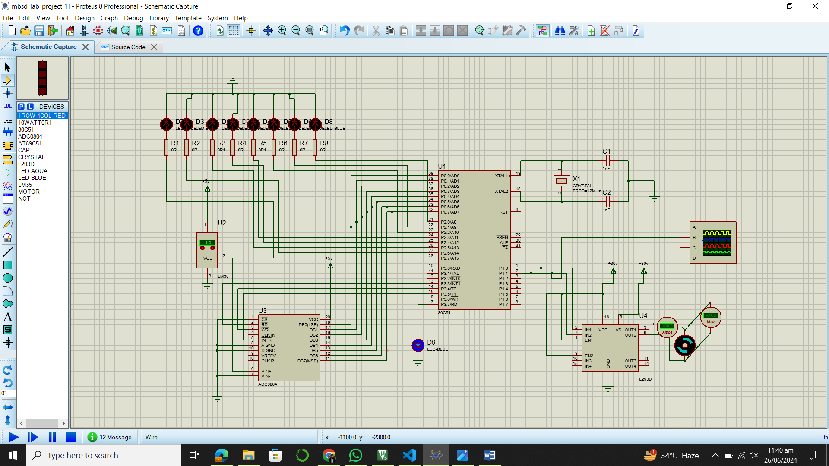

Initially, temperature is 34°C , Fan is off. The temperature became 35°C , Fan is on. The LCD display shows “Normal” The LCD display shows “Overheat”

With temperature unchanged , switch is pressed and “37,” is entered in the virtual terminal. Now, the LCD display shows “Normal” because the TEMP_LIMIT is 37 now but the current temperature is 35. Relay is off.

With temperature unchanged , switch Is pressed and “32,” is entered in the virtual terminal. Now, the LCD display shows “Overheat” because the TEMP_LIMIT is 32 now but the current temperature is 34. Relay is on.

______________________________________________________________________________